
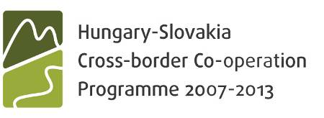

Modification request of ERDF Subsidy Contract

Lead Partner requesting the modification:

Project No <Project code>
With the acronym <acronym>
Entitled <Project title>

Dear Secretariat,

We, as Lead Partner of the above project, request a modification of the ERDF subsidy contract concluded between the National Development Agency and ourselves on the <date> with the items detailed in the followings.

- Article X1.Y1. of the Subsidy Contract is to be modified as follows:

Original text (in force):
Modified text (to be put into addendum of the contract):

Justification for the above modification:
List of documents supporting the request of modification:
  - …………
  - …………
  - …………

- Article X1.Y1. of the Subsidy Contract is to be modified as follows:

Original text (in force):
Modified text (to be put into addendum of the contract):

Justification for the above modification:
List of documents supporting the request of modification:
  - …………
  - …………
  - …………

The above modifications induce changes in the project objectives/results/outputs: | YES
 | NO
If yes, please, describe:

In case the requested modification would result in increasing the overall project costs of the given Partner Organisation, the extra costs will be covered from external sources (above of the Partner’s project budget).

All other provisions of the original Subsidy Contract other than the above defined ones are to remain unchanged and effective. In case the modification will be approved, the amendment will enter into force on the date on which it is signed by all the parties. Such amendments are not ex post facto.

Place and date: ……………………….

Lead Partner represented by
..............................................
<Name>
<Title>

