
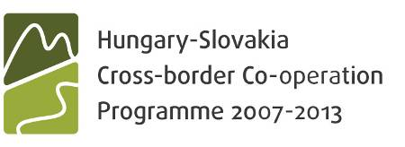

Request for modification
For technical changes not related to conceptual segment
of the project

Project No:
Project title:
Lead Partner name:
Fax:

Short description and justification of the change:
Change of the project manager/financial allocation/etc. The reason of the change is …

Name of the LP/ Project Partner concerned by the change:
…

In case the change involves financial allocation please fill in the table:

Budget line | Original amount (EUR) | Modified amount (EUR) | Amount of the change (EUR)

Place and date: ……………………….

LP represented by
..............................................

THE JTS FILLS IT IN!

Decision:

The change is approved |  | The change is not approved

In case the change is not approved, please explain:

Date when JTS received the LP request:

The change comes into force as of:

In case the requested change would result in increasing the overall project costs of the concerned Project Partner(s), the extra costs will be covered from external sources (above of the Project Partner’s budget).

Place and date: ……………………….

JTS represented by
..............................................

